WEEK 8:
TASK 1:
class Sports {
String getName() {
return "Generic Sports";
}

void getNumberOfTeamMembers() {
System.out.println("Each team has n players in " + getName());
}
}

class Soccer extends Sports {

@Override
String getName() {
return "Soccer Class";
}

@Override
void getNumberOfTeamMembers() {
System.out.println("Each team has 11 players in " + getName());
}
}

public class Solution {
public static void main(String[] args) {
Sports c1 = new Sports();
Soccer c2 = new Soccer();

System.out.println(c1.getName());
c1.getNumberOfTeamMembers();

System.out.println(c2.getName());
c2.getNumberOfTeamMembers();
}
}
OUTPUT :
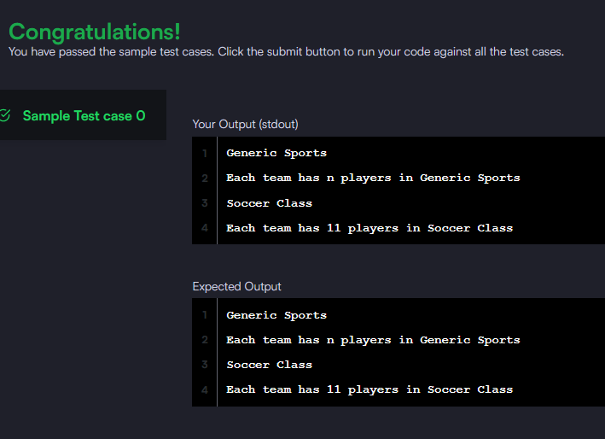

TASK 2 :
class BiCycle {
String define_me() {
return "a vehicle with pedals.";
}
}

class MotorCycle extends BiCycle {

String define_me() {
return "a cycle with an engine.";
}

void print() {
System.out.println("Hello I am a motorcycle, I am " + define_me());

// Call superclass method using super
String temp = super.define_me();
System.out.println("My ancestor is a cycle who is " + temp);
}
}

public class Solution {
public static void main(String[] args) {
MotorCycle M = new MotorCycle();
M.print();
}
}
OUTPUT :
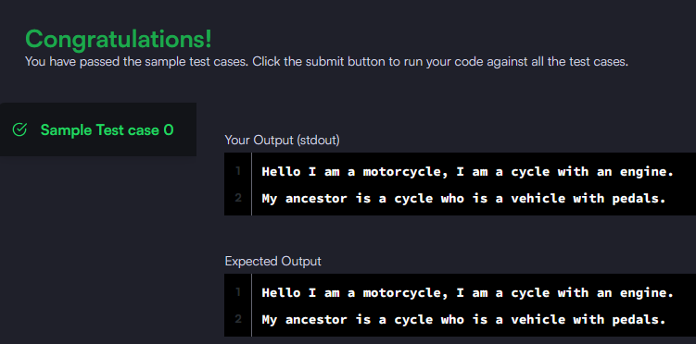
TASK 3 :
import java.util.*;

class Singleton {

public String str;

private static Singleton instance;

private Singleton() {
}

public static Singleton getSingleInstance() {
if (instance == null) {
instance = new Singleton();
}
return instance;
}
}

public class Solution {
public static void main(String[] args) {
Scanner sc = new Scanner(System.in);
String input = sc.nextLine();

Singleton obj = Singleton.getSingleInstance();
obj.str = input;

System.out.println("Hello I am a singleton! Let me say " + obj.str + " to you");
}
}
OUTPUT :
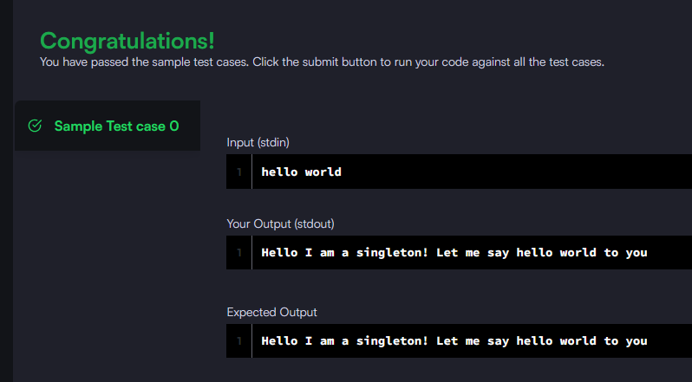
TASK 4 :
import java.util.*;

enum Color {
RED, GREEN
}

abstract class Tree {
private int value;
private Color color;
private int depth;

public Tree(int value, Color color, int depth) {
this.value = value;
this.color = color;
this.depth = depth;
}

public int getValue() { return value; }
public Color getColor() { return color; }
public int getDepth() { return depth; }

public abstract void accept(TreeVis visitor);
}

class TreeNode extends Tree {
private ArrayList<Tree> children = new ArrayList<>();

public TreeNode(int value, Color color, int depth) {
super(value, color, depth);
}

public void addChild(Tree child) {
children.add(child);
}

public void accept(TreeVis visitor) {
visitor.visitNode(this);
for (Tree child : children) {
child.accept(visitor);
}
}
}

class TreeLeaf extends Tree {
public TreeLeaf(int value, Color color, int depth) {
super(value, color, depth);
}

public void accept(TreeVis visitor) {
visitor.visitLeaf(this);
}
}

abstract class TreeVis {
public abstract int getResult();
public abstract void visitNode(TreeNode node);
public abstract void visitLeaf(TreeLeaf leaf);
}

// Visitor 1
class SumInLeavesVisitor extends TreeVis {
int sum = 0;

public int getResult() { return sum; }

public void visitNode(TreeNode node) {}

public void visitLeaf(TreeLeaf leaf) {
sum += leaf.getValue();
}
}

// Visitor 2
class ProductRedNodesVisitor extends TreeVis {
long product = 1;
final int MOD = 1000000007;

public int getResult() { return (int) product; }

public void visitNode(TreeNode node) {
if (node.getColor() == Color.RED)
product = (product * node.getValue()) % MOD;
}

public void visitLeaf(TreeLeaf leaf) {
if (leaf.getColor() == Color.RED)
product = (product * leaf.getValue()) % MOD;
}
}

// Visitor 3
class FancyVisitor extends TreeVis {
int evenDepthSum = 0;
int greenLeafSum = 0;

public int getResult() {
return Math.abs(evenDepthSum - greenLeafSum);
}

public void visitNode(TreeNode node) {
if (node.getDepth() % 2 == 0)
evenDepthSum += node.getValue();
}

public void visitLeaf(TreeLeaf leaf) {
if (leaf.getColor() == Color.GREEN)
greenLeafSum += leaf.getValue();
}
}

public class Solution {

static Map<Integer, List<Integer>> map = new HashMap<>();

public static Tree buildTree(int node, int depth, int[] values, int[] colors, boolean[] visited) {
visited[node] = true;

Tree tree;
if (map.get(node).size() == 1 && node != 1) {
tree = new TreeLeaf(values[node - 1],
colors[node - 1] == 0 ? Color.RED : Color.GREEN,
depth);
} else {
tree = new TreeNode(values[node - 1],
colors[node - 1] == 0 ? Color.RED : Color.GREEN,
depth);

for (int child : map.get(node)) {
if (!visited[child]) {
((TreeNode) tree).addChild(buildTree(child, depth + 1, values, colors, visited));
}
}
}
return tree;
}

public static void main(String[] args) {
Scanner sc = new Scanner(System.in);

int n = sc.nextInt();

int[] values = new int[n];
for (int i = 0; i < n; i++) values[i] = sc.nextInt();

int[] colors = new int[n];
for (int i = 0; i < n; i++) colors[i] = sc.nextInt();

for (int i = 1; i <= n; i++) map.put(i, new ArrayList<>());

for (int i = 0; i < n - 1; i++) {
int u = sc.nextInt();
int v = sc.nextInt();
map.get(u).add(v);
map.get(v).add(u);
}

boolean[] visited = new boolean[n + 1];
Tree root = buildTree(1, 0, values, colors, visited);

SumInLeavesVisitor vis1 = new SumInLeavesVisitor();
ProductRedNodesVisitor vis2 = new ProductRedNodesVisitor();
FancyVisitor vis3 = new FancyVisitor();

root.accept(vis1);
root.accept(vis2);
root.accept(vis3);

System.out.println(vis1.getResult());
System.out.println(vis2.getResult());
System.out.println(vis3.getResult());
}
}
OUTPUT :
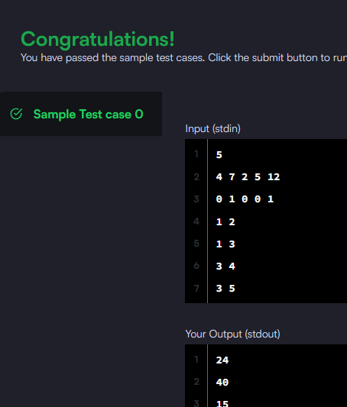
TASK 5 :
import java.util.*;

public class Solution {

static void func(ArrayList mylist){
Iterator it = mylist.iterator();

while(it.hasNext()){
Object element = it.next();
if(element.equals("###")) break;
}

while(it.hasNext()){
System.out.println(it.next());
}
}

public static void main(String []args){
Scanner sc = new Scanner(System.in);
ArrayList mylist = new ArrayList();

int n = sc.nextInt(); // number of integers
int m = sc.nextInt(); // number of strings

for(int i = 0; i < n; i++){
mylist.add(sc.nextInt());
}

mylist.add("###");

for(int i = 0; i < m; i++){
mylist.add(sc.next());
}

func(mylist);
}
}
OUTPUT :
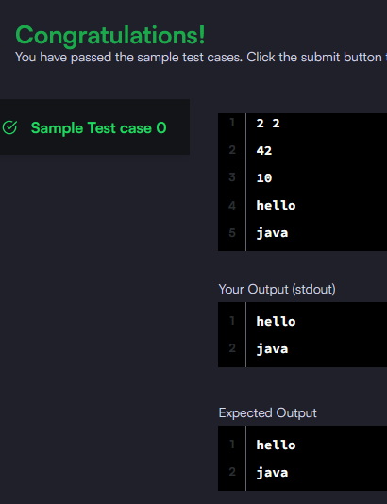
TASK 6 :
import java.util.*;

interface AdvancedArithmetic {
int divisor_sum(int n);
}

class MyCalculator implements AdvancedArithmetic {

public int divisor_sum(int n) {
int sum = 0;

for (int i = 1; i <= n; i++) {
if (n % i == 0) {
sum += i;
}
}

return sum;
}
}

public class Solution {
public static void main(String[] args) {
MyCalculator my_calculator = new MyCalculator();
Scanner sc = new Scanner(System.in);
int n = sc.nextInt();

System.out.println("I implemented: AdvancedArithmetic");
System.out.println(my_calculator.divisor_sum(n));
}
}
OUTPUT :
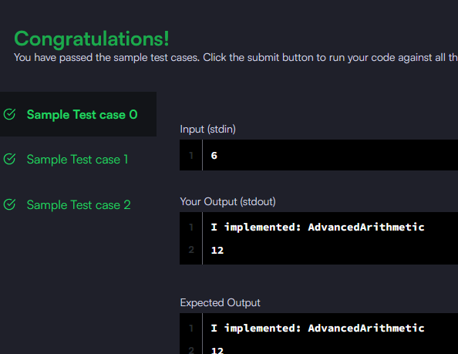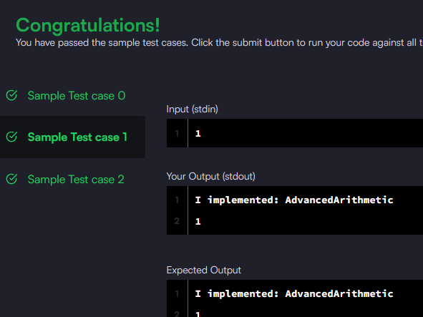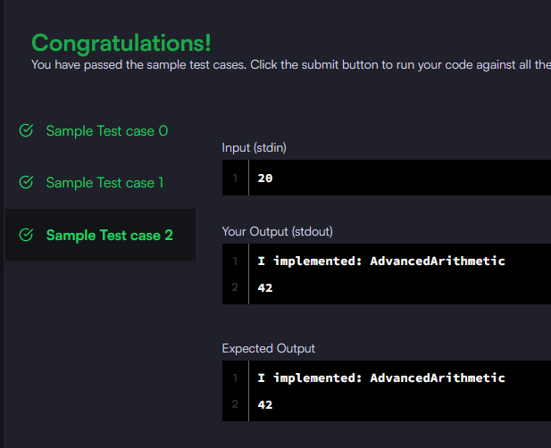
TASK 7 :
import java.util.*;

public class Solution {

public static void main(String[] args) {
Scanner sc = new Scanner(System.in);

int t = sc.nextInt();
HashSet<String> set = new HashSet<>();

for (int i = 0; i < t; i++) {
String first = sc.next();
String second = sc.next();

String pair = first + " " + second;
set.add(pair);

System.out.println(set.size());
}

sc.close();
}
}
OUTPUT :
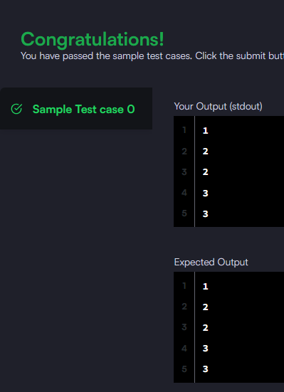
TASK 8 :
import java.util.*;

class Arithmetic {
int add(int a, int b) {
return a + b;
}
}

class Adder extends Arithmetic {
}

public class Solution {
public static void main(String[] args) {
Adder a = new Adder();

System.out.println("My superclass is: " + a.getClass().getSuperclass().getName());
System.out.print(a.add(10, 32) + " " + a.add(10, 3) + " " + a.add(10, 10));
}
}
OUTPUT :
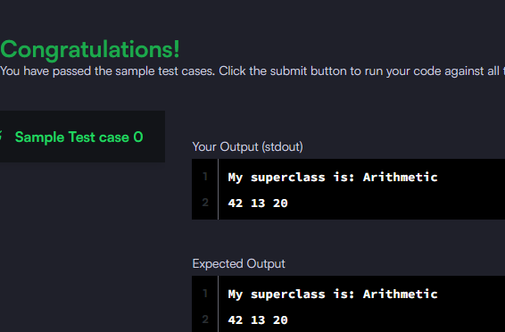
TASK 9 :
import java.util.*;

class MyCalculator {

long power(int n, int p) throws Exception {

if (n == 0 && p == 0) {
throw new Exception("n and p should not be zero.");
}

if (n < 0 || p < 0) {
throw new Exception("n or p should not be negative.");
}

return (long) Math.pow(n, p);
}
}

public class Solution {
public static void main(String[] args) {
Scanner sc = new Scanner(System.in);
MyCalculator my_calculator = new MyCalculator();

while (sc.hasNextInt()) {
int n = sc.nextInt();
int p = sc.nextInt();

try {
System.out.println(my_calculator.power(n, p));
} catch (Exception e) {
System.out.println(e);
}
}
sc.close();
}
}
OUTPUT :
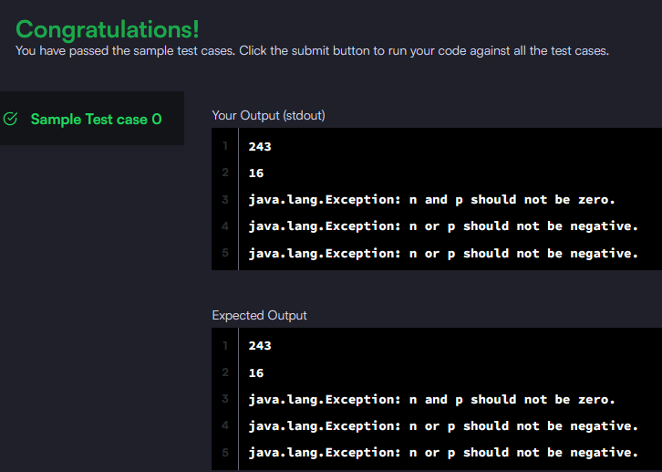
TASK 10 :
import java.util.*;

public class Solution {
public static void main(String[] args) {
Scanner sc = new Scanner(System.in);

try {
int x = sc.nextInt();
int y = sc.nextInt();

int result = x / y;
System.out.println(result);

} catch (InputMismatchException e) {
System.out.println("java.util.InputMismatchException");
} catch (ArithmeticException e) {
System.out.println(e);
}
}
}
OUTPUT :
